Press release

IKEA expands the ongoing chocolate recall by 6 further products, which are not suitable for persons allergic or sensitive to hazelnut and/or almond.

/Image of the products/ Please find list of PE-numbers below:
GODIS CHOKLADKROKANT MILK 450G | PE292699
GODIS CHOKLADRÅN CHOC WAFERS 168G | PE596811
CHOKLAD NÖT CHOC HAZELNUTS UTZ 100G | PE554316
CHOKLAD LJUS MILK CHOC BAR UTZ 100G | PE554313
CHOKLAD LINGON & BLÅBÄR CHOC 180G | PE295260
CHOKLADKROKANT BREDBAR CHOC 400G | PE334894

Thursday 28th of July 2016

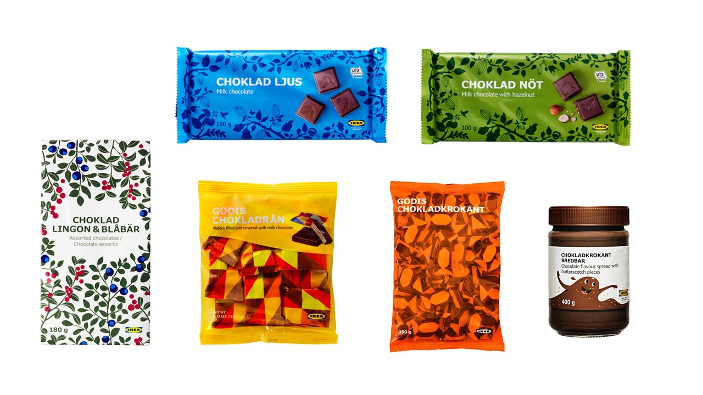

IKEA wants customers who have bought one or more of the affected IKEA chocolate products to be informed that these products are not suitable for persons allergic or sensitive to hazelnut and/or almond, and are therefore being recalled by IKEA.

IKEA expands the ongoing chocolate recall by 6 further IKEA chocolate products, which are not suitable for persons allergic or sensitive to hazelnut and/or almond.

Product safety and quality are of highest priority to IKEA and the global recall concern all best before dates of all affected products.

The presence of hazelnut and almond has been frequently and not only occasionally detected, which underlines that these chocolate products are not suitable for consumption by persons allergic or sensitive to those allergens.
The product information is not stating this frequent presence clearly enough as the product labels only state “may contain…”. The product information on the product label could possibly be misleading and is therefore not interpreted as compliant with legislation in several markets. Based on the high IKEA safety and quality standards we have decided to recall the affected products globally, irrespective of various legislations in our markets.

The products are safe for anyone not allergic or sensitive to almond and/or hazelnut. IKEA has no allergic incident reported in connection with the additional 6 products added to the ongoing chocolate recall.

Concerned customers are welcome to return affected products at the nearest IKEA store at a full refund.

We are sorry for any inconvenience this may cause.

For more information, please contact IKEA toll-free XXXX.

Additional 6 chocolate products under recall | Sales Period
CHOKLAD LINGON & BLÅBÄR 180 g  (chocolate with lingon/blueberry flavour) | All best before dates
CHOKLAD LJUS UTZ 100g  (milk chocolate bar) | All best before dates
CHOKLAD NÖT UTZ 100g  (milk chocolate bar with hazelnut) | All best before dates
GODIS CHOKLADKROKANT 450g  (milk chocolate with butterscotch) | All best before dates
GODIS CHOKLADRÅN 168g  (chocolate filled wafers) | All best before dates
CHOKLADKROKANT BREDBAR 400g  (chocolate butterscotch spread) | All best before dates

