Landgraaf, 12 - 02 - 2026.

Subject: Recall: Snack corn chick./lech.man. BOY-B bg90g bbf div

Dear Customer,

The Quality Department of Heuschen & Schrouff is continuously monitoring our products, so that we can always offer you the highest quality. Recent research has shown that the product Snack corn chick./lech.man. BOY-B bg90g contains Wheat. Wheat is not listed on the label. Based on this investigation we have to recall the following product:
Brand: | BOY BAWANG | 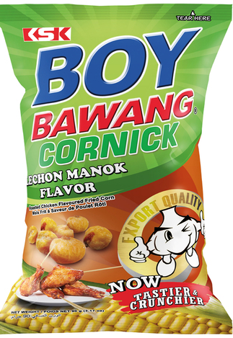
Product name: | Snack corn chick./lech.man.
Contents: | 40 x 90 g
Item No.: | 04133

Batch Code:
BBD: | Div.

- We hereby request you to remove the products from the shelves directly.
- If you have delivered this product to other companies, you have to inform these companies.
- We also ask you to get in touch with your contact person at our company, so that you can pass on the quantities and we can schedule an arrangement to return the goods. These products will of course be fully credited to your account, or use our online return form: https://www.heuschenschrouff.com/en/retour-en-manco-formulier/

We apologize for any inconvenience this may cause and thank you very much for your cooperation.

Kind regards,

Quality Department
Heuschen & Schrouff Oriental Food

